Task #1
Run Ubuntu container
Pass -e COLLEGE=CSE
Show echo $COLLEGE
Stop container then check what happened

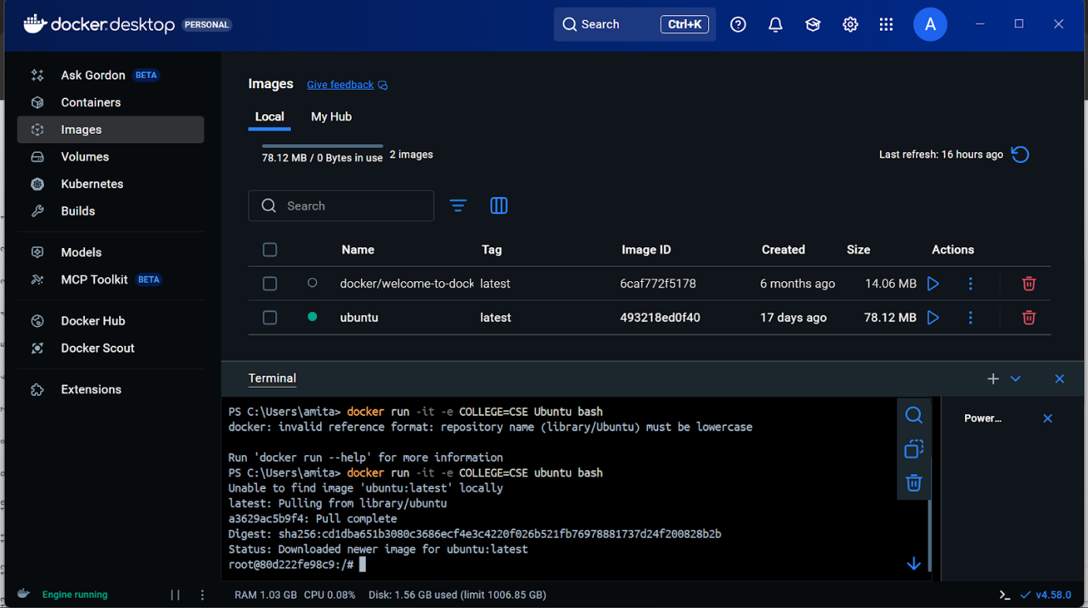
Commands: docker run -it -e COLLEGE=CSE ubuntu bash

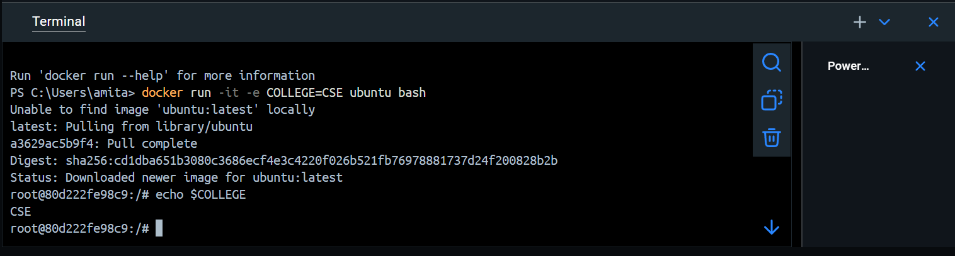

Commands: echo $COLLEGE

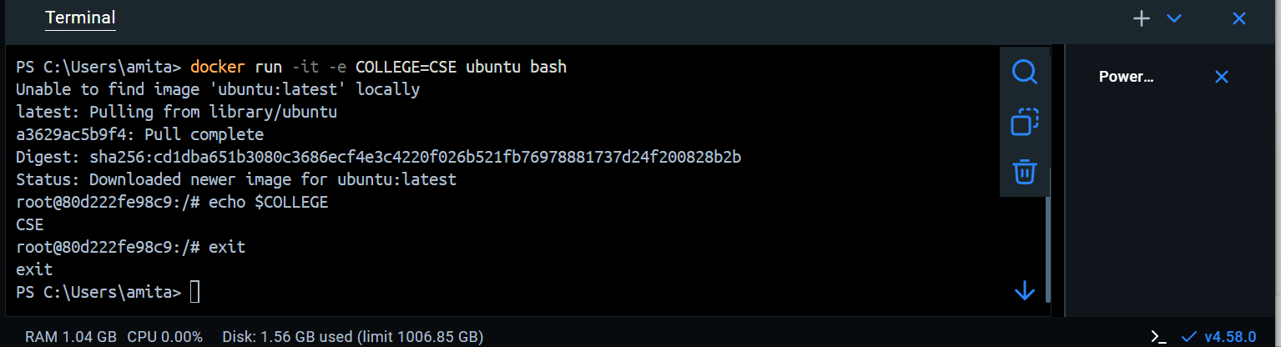
Commands : exit or docker stop root@80d222fe98c9

Practice Questions on Basic Docker Commands

Run a Docker container named “DB-app” based on the “mongodb” image, and expose port 80 on the host to port 8082 on the container?
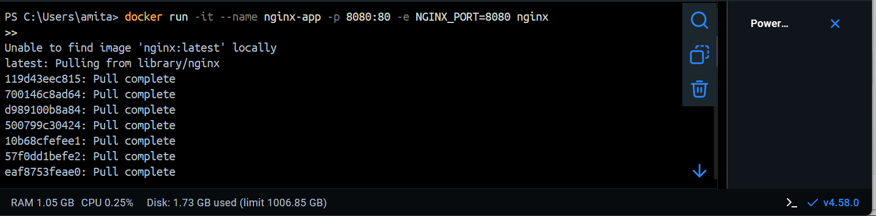

Run a Docker container based on the nginx image, exposing port 8080 on the host port 80 on the container . Set an environment variable NGINX_PORT=8080 inside the container and start the container interactively.

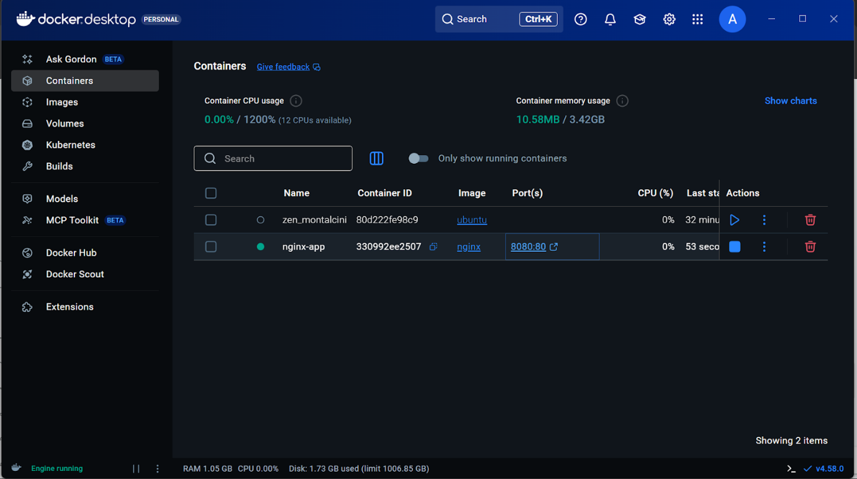

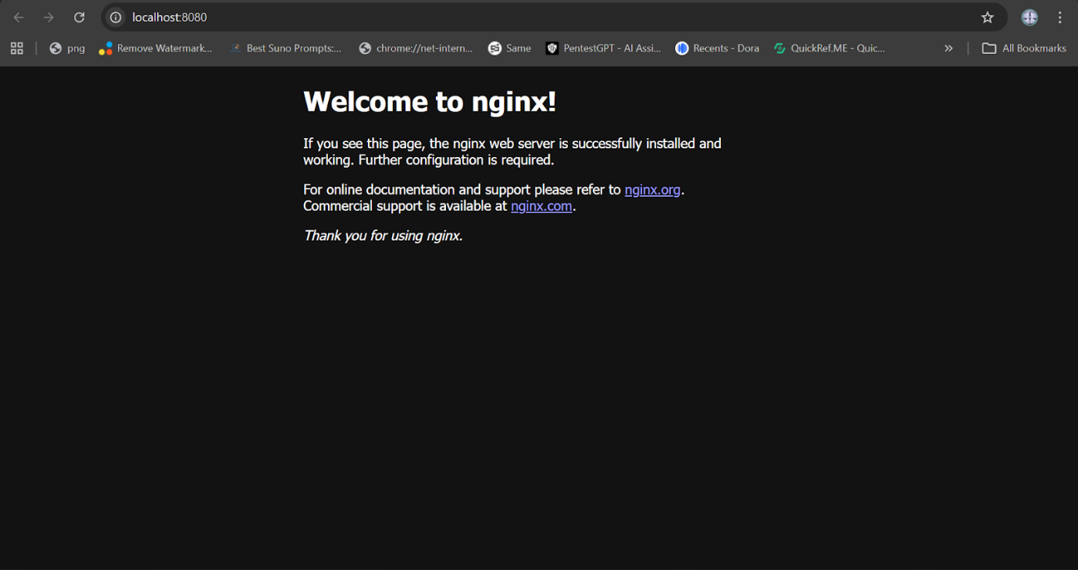

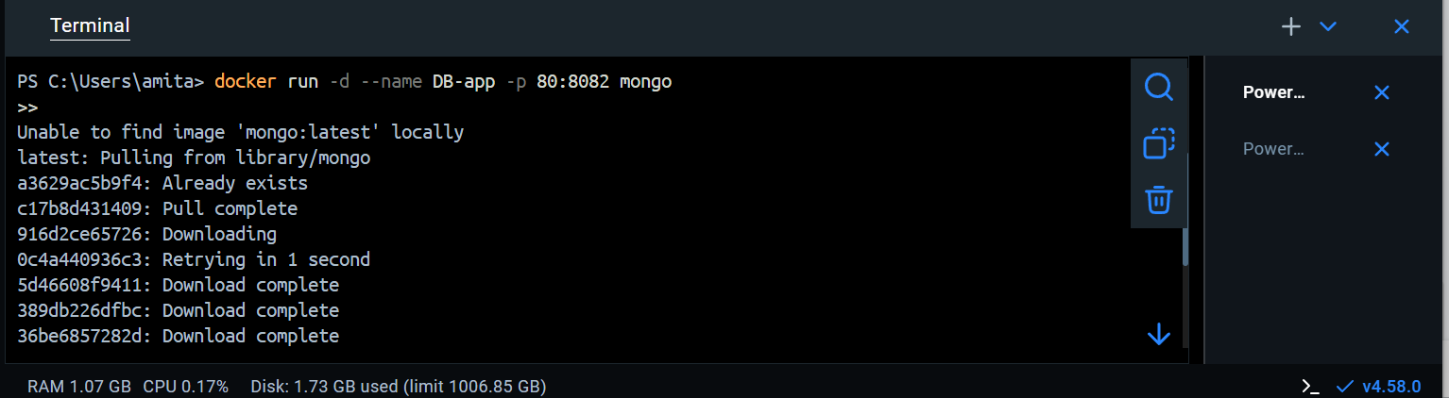

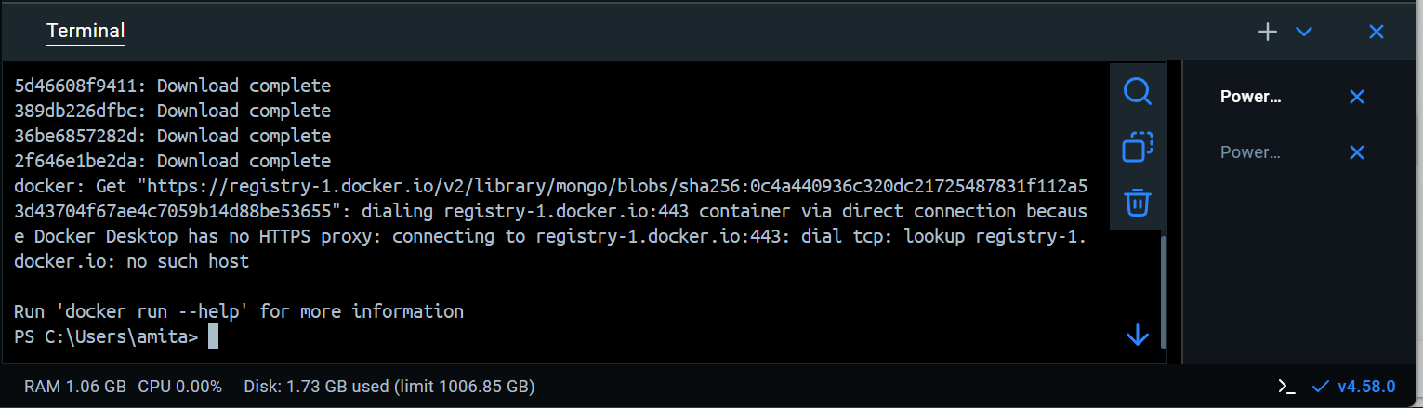

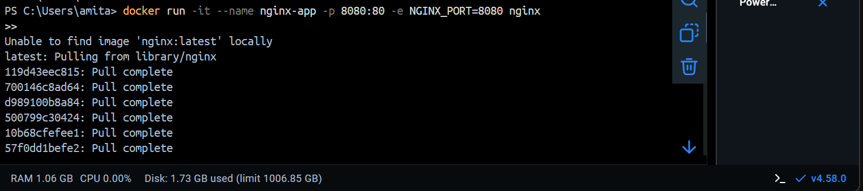

3. How would you use the docker run command with -it , -e , -v and –name to:
Set an environment variable APP_ENV=production.
Name the container my_app.
Start an interactive terminal in an image called my_image?

Write the full commands for the scenario above.

Commands: docker run -it --name my_app -e APP_ENV=production -v $(pwd):/app my_image /bin/bash

Example 1
Mkdir C:\docker-volume-demo
Echo “hello from HOST machine > C:\docker-volume-demo\hostfile.txt
Docker run -it --name cv1 -v c:\docker-volume-demo:/data ubuntu bash

Container
ls
Cd data
Cat hostfile.txt
Modify file inside container
Echo “Modified inside container” >> /data/hostfile.txt
Exit

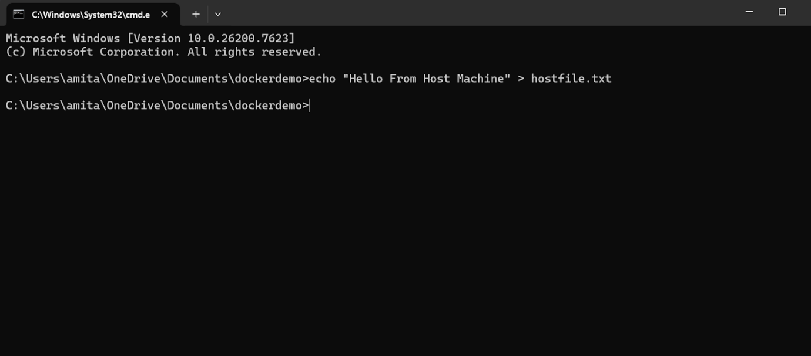

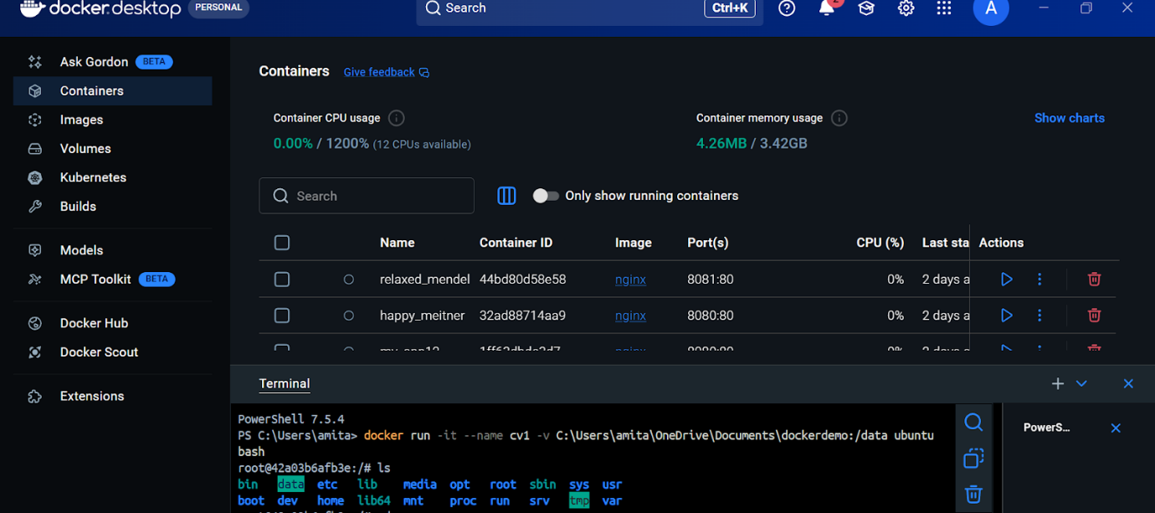

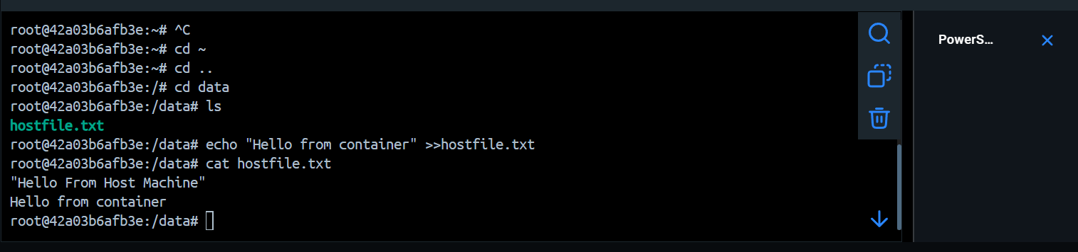

Practice Question

Create a Docker volume named studentdata.
Run an Ubuntu container and mount studentdata at /student.
Create a file inside the container and verify it persists after container deletion.
Attach the same volume to another container and verify the file exists.
Demonstrate data sharing between two containers using a shared volume.
Show that deleting a container does NOT delete the volume data.

